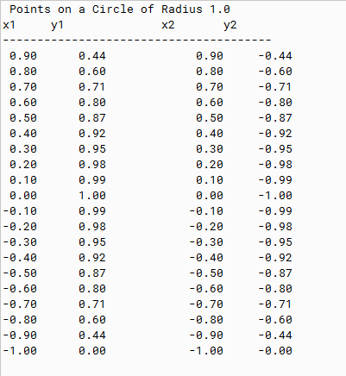

PMR: This program was easy to create and was a good review of the concepts we have learned so far

/\*

\* Project title: 07.01 Javas Math Class

\*

\* Purpose of Project: Calculates the points on a circle of radius 1.0.

\*

\* @version 11/12/2019

\*

\* @author Anika Jallipalli

\*

\* \*\*\*\*\*\*\*\*\*\*\* PMR \*\*\*\*\*\*\*\*\*\*\*

\* (+) Got for loops better.

\*

\* (-) Practice printf.

\* \*\*\*\*\*\*\*\*\*\*\*\*\*\*\*\*\*\*\*\*\*\*\*\*\*\*\*

\*

\* In the future: Practice and use eImacs.

\*

\*/

public class CirclePoints{

public static void main(String[] args) {

//Input

double radius = 1.0;

double x = 1.0;

double y = 1.0;

//Output

System.out.println("Points on a Circle of Radius " +radius);

System.out.println("x1 y1 x2 y2");

System.out.println("---------------------------------------");

for(int counter = 0; counter < 20; counter++){

x-= 0.1;

double solveY = Math.sqrt((Math.pow(radius, 2) - Math.pow(x, 2)));

System.out.printf("%5.2f %5.2f %5.2f %5.2f\n" , x, solveY, x, -1 \* solveY);

}

}

}